ATDP 34,486

Binding and Functional Activity at D1, D2, D3 and D4.4 Dopamine Receptors and
5HT1A, 5HT2A, 5HT2B and 5HT2C Serotonin Receptors

Atheir I. Abbas, MD, PhD
Assistant Professor of Behavioral Neuroscience and Psychiatry
Oregon Health & Science University
Research Service, VAPORHCS
Portland OR, 97239

Aaron Janowsky, Ph.D.
Professor of Psychiatry, Physiology & Pharmacology, and Behavioral Neuroscience,
Oregon Health & Science University, and
Research Career Scientist, VA Medical Center
Portland OR, 97239

Department of Health and Human Services/Department of Veterans Affairs Interagency Agreement No. IAA ADA20003

Title: "In vitro receptor and transporter assays for NIDA medications discovery and abuse liability testing”

Atheir I. Abbas, M.D., Ph.D., Assistant Professor
Depts of Behavioral Neuroscience and Psychiatry, Oregon Health & Science University
Psychiatrist, Portland VA Medical Center
3710 S.W. U.S. Veterans Hospital Rd., Portland, OR 97239
Phone: (503) 220-8626 x59488; FAX: (503) 721-7839
Email: abbasat@OHSU.edu

Summary:
Compound 34,486 has very low affinity for the DA D1 receptor, high affinity for the DA D2 receptor, very high affinity for the DA D3 and low affinity for the DA D4.4 receptors. Affinities are based on Ki values.

Binding affinity met criterion for functional testing (<500 nM) at the DA D2, DA D3 and DA D4.4 receptors, therefore functional assays were conducted. Affinities are based on Ki values. 34,486 is a high potency partial agonist at the DA D2 and the DA D3 receptor, and a moderate potency partial agonist with no antagonist effect, at the DA D4.4 receptor.

Compound 34,486 has moderate affinity for 5HT1A and 5HT2A receptors, high affinity for 5HT2B receptors, and very low affinity for 5HT2C receptors. Affinities are based on Ki values.

Binding affinity met criterion for functional testing (<250 nM) at the 5HT1A, 5HT2A, 5HT2B receptors, therefore functional assays were conducted. At the 5HT1A receptor, 34,486 has moderate potency as a partial to full agonist. At the 5HT2A receptor 34,486 has moderate potency as a partial agonist. At the 5HT2B receptor, 34,486 has moderate potency as an antagonist.

Abbreviations:
5HT1A – serotonin 1A receptor
5HT2A – serotonin 2A receptor
5HT2B – serotonin 2B receptor
5HT2C – serotonin 2C receptor
DA D1 – dopamine D1 receptor
DA D2 – dopamine D2 receptor
DA D3 – dopamine D3 receptor
DA D4.4 – dopamine D4.4 receptor

Binding Assay Results for Compound 34,486

Receptor [³H]Ligand | IC₅₀ (nM) | K_{i} (nM) ± SEM | Hill Slope ± SEM
DA D1 [³H] SCH23390 | 6540 ± 210 | 4700 ± 140 | -1.34 ± 0.07
DA D2 [³H] Spiperone | 25.0 ± 4.0 | 5.35 ± 0.83 | -1.33 ± 0.15
DA D3 [³H] Spiperone | 0.68 ± 0.14 | 0.307 ± 0.069 | -1.48 ± 0.14
DA D4.4 [³H] Spiperone | 614 ± 85 | 284 ± 42 | -0.89 ± 0.10
5HT1A [³H]8-OH-DPAT | 20.1 ± 5.7 | 18.7 ± 5.3 | -0.97 ± 0.14
5HT2A [³H]5-HT | 105 ± 37 | 58 ± 20 | -1.21 ± 0.18
5HT2B [³H]5-HT | 2.40 ± 0.77 | 1.14 ± 0.36 | -0.58 ± 0.25
5HT2C [³H]5-HT | 740 ± 170 | 530 ± 110 | -0.93 ± 0.18

Affinity and potency: Definitions of binding (Ki) and agonist (EC₅₀) and antagonist (IC₅₀) categories: |  | Efficacy: Definition of functional agonist and antagonist categories:
Parameter value | Category | Stimulation% | Category of efficacy
<1.0 nM | Very high affinity or potency | ≥ 90% | Full
1-10 nM | High potency or affinity | 70-90% | Partial to full
10-100 nM | Moderate affinity or potency | <70% | Partial
100-500 nM | Low affinity or potency | 0-20% | Possible antagonist
500 nM-10,000 nM | Very low affinity or potency
>10 μM | No measurable affinity or potency

Functional Assay Results for Compound 34,486
Receptor | Agonist EC50 (nM) ± SEM | Standard agonist | % Stimulation compared to standard agonist | Antagonist IC50 (nM) ± SEM | Standard antagonist | % Inhibition compared to standard antagonist
DA D1 cAMP Assay | ND | Dopamine | ND | ND | SCH-23390 | ND
DA D2 mitogenesis | 9.8 ± 1.5 | Quinpirole | 45.8 ± 4.4% | 65 ± 11 | Butaclamol | 39 ± 12%
DA D3 mitogenesis | 1.27 ± 0.39 | Quinpirole | 30.8 ± 3.5% | 29 ± 10 | Butaclamol | 63.1 ± 4.1%
DA D4.4 cAMP Assay | 72 ± 19 | Quinpirole | 57.5 ± 4.5% | >10,000 | Haloperidol
5HT1A [³⁵S] GTPγS Assay | 33.3 ± 8.2 | Serotonin | 89.6 ± 3.1% | ND | WAY100,635
5HT2A IP-1 formation | 39.0 ± 6.0 | Serotonin | 23.0 ± 6.3% | 213 ± 68 | Ketanserin | 67.1 ± 6.6%
5HT2B IP-1 formation | >10,000 | Serotonin | <4.0% | 26.2 ± 5.8 | RS127445 | 92.2 ± 5.1%
5HT2C IP1 formation | ND | Serotonin | ND | ND | SB242084 | ND
Functional assays for each receptor are not conducted if the Ki value for the binding assay is greater than 500 nM (DA receptors) or 250 nM (5-HT receptors).

Dopamine receptors binding and functional results
 |  | Standard | Standard | Standard
LhD1 | 34,486 | SCH-23390 | SKF-38393
[³H]SCH23390 Binding Ki (nM) | 4,700 ± 140 | 0.721 ± 0.045 | 284 ± 42
Hill coefficient | -1.34 ± 0.07 | -0.98 ± 0.07 | -0.70 ± 0.04
Number of experiments | 3
Adenylate cyclase | 34,486
Stimulation EC₅₀ (nM) | ND
Maximal stimulation (%)
Number of experiments
CHOp-D2 | 34,486 | Butaclamol | Quinpirole
[³H]Spiperone Binding Ki (nM) | 5.35 ± 0.83 | 0.546 ± 0.027 | 2110 ± 130
Hill coefficient | -1.33 ± 0.15 | -1.18 ± 0.02 | -0.74 ± 0.02
Number of experiments | 3
Mitogenesis | 34,486 | Dopamine | Quinpirole
Stimulation EC₅₀ (nM) | 9.8 ± 1.5 | 16.4 ± 1.8 | 10.5 ± 1.2
Maximal stimulation (%) | 45.8 ± 4.4% | 97.7 ± 2.7% | 100.84 ± 0.49%
Number of experiments | 4 |  |  | Butaclamol
Inhibition IC₅₀ (nM) | 65 ± 11 |  |  | 2.36 ± 0.16
Maximal inhibition (%) | 39 ± 12% |  |  | 93.6 ± 1.4%
Number of experiments | 3
CHOp-D3 | 34,486 | Butaclamol | Quinpirole | NGB 2904
[³H]Spiperone Binding Ki (nM) | 0.307 ± 0.069 | 3.16 ± 0.31 | 40.1 ± 8.5 | 0.76 ± 0.13
Hill coefficient | -1.48 ± 0.14 | -1.09 ± 0.08 | -0.79 ± 0.09 | -1.34 ± 0.16
Number of experiments | 3
Mitogenesis | 34,486 | Dopamine | Quinpirole
Stimulation EC₅₀ (nM) | 1.27 ± 0.39 | 1.84 ± 0.62 | 2.73 ± 0.27
Maximal stimulation (%) | 30.8 ± 3.5% | 101.5 ± 4.1% | 100.61 ± 0.81%
Number of experiments | 9 |  |  | Butaclamol
Inhibition IC₅₀ (nM) | 29 ± 10 |  |  | 57 ± 10
Maximal inhibition (%) | 63.1 ± 4.1% |  |  | 95.1 ± 1.6%
Number of experiments | 11
HEK-D4.4-AC1 | 34,486 | Haloperidol | Quinpirole
[³H]Spiperone Binding Ki (nM) | 284 ± 42 | 2.95 ± 0.83 | 121 ± 33
Hill coefficient | -0.89 ± 0.10 | -0.75 ± 0.04 | -0.71 ± 0.02
Number of experiments | 3
Forskolin-stimulated cAMP | 34,486 | Dopamine | Quinpirole
Agonist inhibition EC₅₀ (nM) | 72 ± 19 | 2.71 ± 0.77 | 1.48 ± 0.28
Maximal effect (% quin max) | 57.5 ± 4.5% | 97.9 ± 2.2% | 98.1 ± 2.7%
Number of experiments | 3 |  |  | Haloperidol
Antagonist inhibition IC₅₀ (nM) | >10,000 |  |  | 47.2 ± 4.1
Maximal effect (% reveral quin max) | * |  |  | 151 ± 11%
Number of experiments | 3

Numbers represent the means ± SEM from at least three independent experiments, each conducted with duplicate determinations. When the K_{i} or the IC₅₀ for the test compound is greater than 10 M, only two experiments are conducted and no standard error or hill slope is reported. A Hill coefficient other than one suggests complex interactions with binding sites. Standard antagonists are SCH 23390 (D1), butaclamol (D2, D3), NGB 2904 (D3) and haloperidol (D4.4). Standard agonists are SKF-38393 (D1), quinpirole (D2, D3, D4.4) and dopamine (D4.4).
*No Hill slope or SEM was calculated due to the low affinity or potency of the compound.
ND- Functional assays for each receptor are not conducted if the Ki value for the binding assay is greater than 500 nM

Serotonin receptors binding and functional results
 |  | Standards | Standards
HEK-h5HT1A | 34,486 | Serotonin | WAY100,635
[³H]8OH-DPAT Binding Ki (nM) | 18.7 ± 5.3 | 2.10 ± 0.45 | 0.81 ± 0.14
Hill coefficient | -0.97 ± 0.14 | -0.75 ± 0.05 | -1.26 ± 0.16
Number of experiments | 8
[³⁵S]GTPγS binding | 34,486 | Serotonin
Stimulation EC₅₀ (nM) | 33.3 ± 8.2 | 3.30 ± 0.45
Maximal stimulation (%) | 89.6 ± 3.1% | 100 ± 0.0%
Number of experiments | 5
HEK-h5HT2A | 34,486 | Serotonin | Ketanserin
[³H]5-HT Binding Ki (nM) | 58 ± 20 | 32.7 ± 4.6 | 2.08 ± 0.64
Hill coefficient | -1.21 ± 0.18 | -1.04 ± 0.09 | -0.34 ± 0.20
Number of experiments | 8
Inositol-1-phosphate (IP-1) formation | 34,486 | Serotonin
Stimulation EC₅₀ (nM) | 39.0 ± 6.0 | 22.4 ± 5.8
Maximal stimulation (%) | 23.0 ± 6.3% | 96.7 ± 2.1%
Number of experiments | 4 |  | Ketanserin
Inhibition IC₅₀ (nM) | 213 ± 68 |  | 11.2 ± 2.5
Maximal inhibition (%) | 67.1 ± 6.6% |  | 97.7 ± 3.8%
Number of experiments | 5
HEK-h5HT2B | 34,486 | Serotonin | RS127445
[³H]5-HT Binding Ki (nM) | 1.14 ± 0.36 | 5.84 ± 0.95 | 0.58 ± 0.12
Hill coefficient | -0.58 ± 0.25 | -0.92 ± 0.09 | -0.56 ± 0.07
Number of experiments | 5
Inositol-1-phosphate (IP-1) formation | 34,486 | Serotonin
Stimulation EC₅₀ (nM) | >10,000 | 19.8 ± 6.3
Maximal stimulation (%) | <4% | 101.8 ± 1.8%
Number of experiments | 2 |  | RS127445
Inhibition IC₅₀ (nM) | 26.2 ± 5.8 |  | 3.55 ± 0.57
Maximal inhibition (%) | 92.2 ± 5.1% |  | 99.01 ± 0.99%
Number of experiments | 4
HEK-h5HT2C | 34,486 | Serotonin | SB242084
[³H]5-HT Binding Ki (nM) | 530 ± 110 | 10.9 ± 2.5 | 2.05 ± 0.73
Hill coefficient | -0.93 ± 0.18 | -1.05 ± 0.06 | -1.39 ± 0.45
Number of experiments | 5
Inositol-1-phosphate (IP-1) formation | 34,486
Agonist inhibition EC₅₀ (nM) | ND
Maximal effect (% quin max)
Number of experiments

Numbers represent the means ± SEM from at least three independent experiments, each conducted with duplicate determinations. A Hill coefficient other than one suggests complex interactions with binding sites. Standard compounds for the 5HT1A receptor are the agonist serotonin and the antagonist WAY 100,635. Standard compounds for the 5HT2A receptor are the agonist serotonin and the antagonist ketanserin. Standard compounds for the 5HT2B receptor are the agonist serotonin and the antagonist RS127445. Standard compounds for the 5HT2C receptor are the agonist serotonin and the antagonist SB 242,084.
ND- Functional assays for each receptor are not conducted if the Ki value for the binding assay is greater than 250 nM.
*No SEM was calculated due to the low potency of the compound.
Dopamine receptor binding results

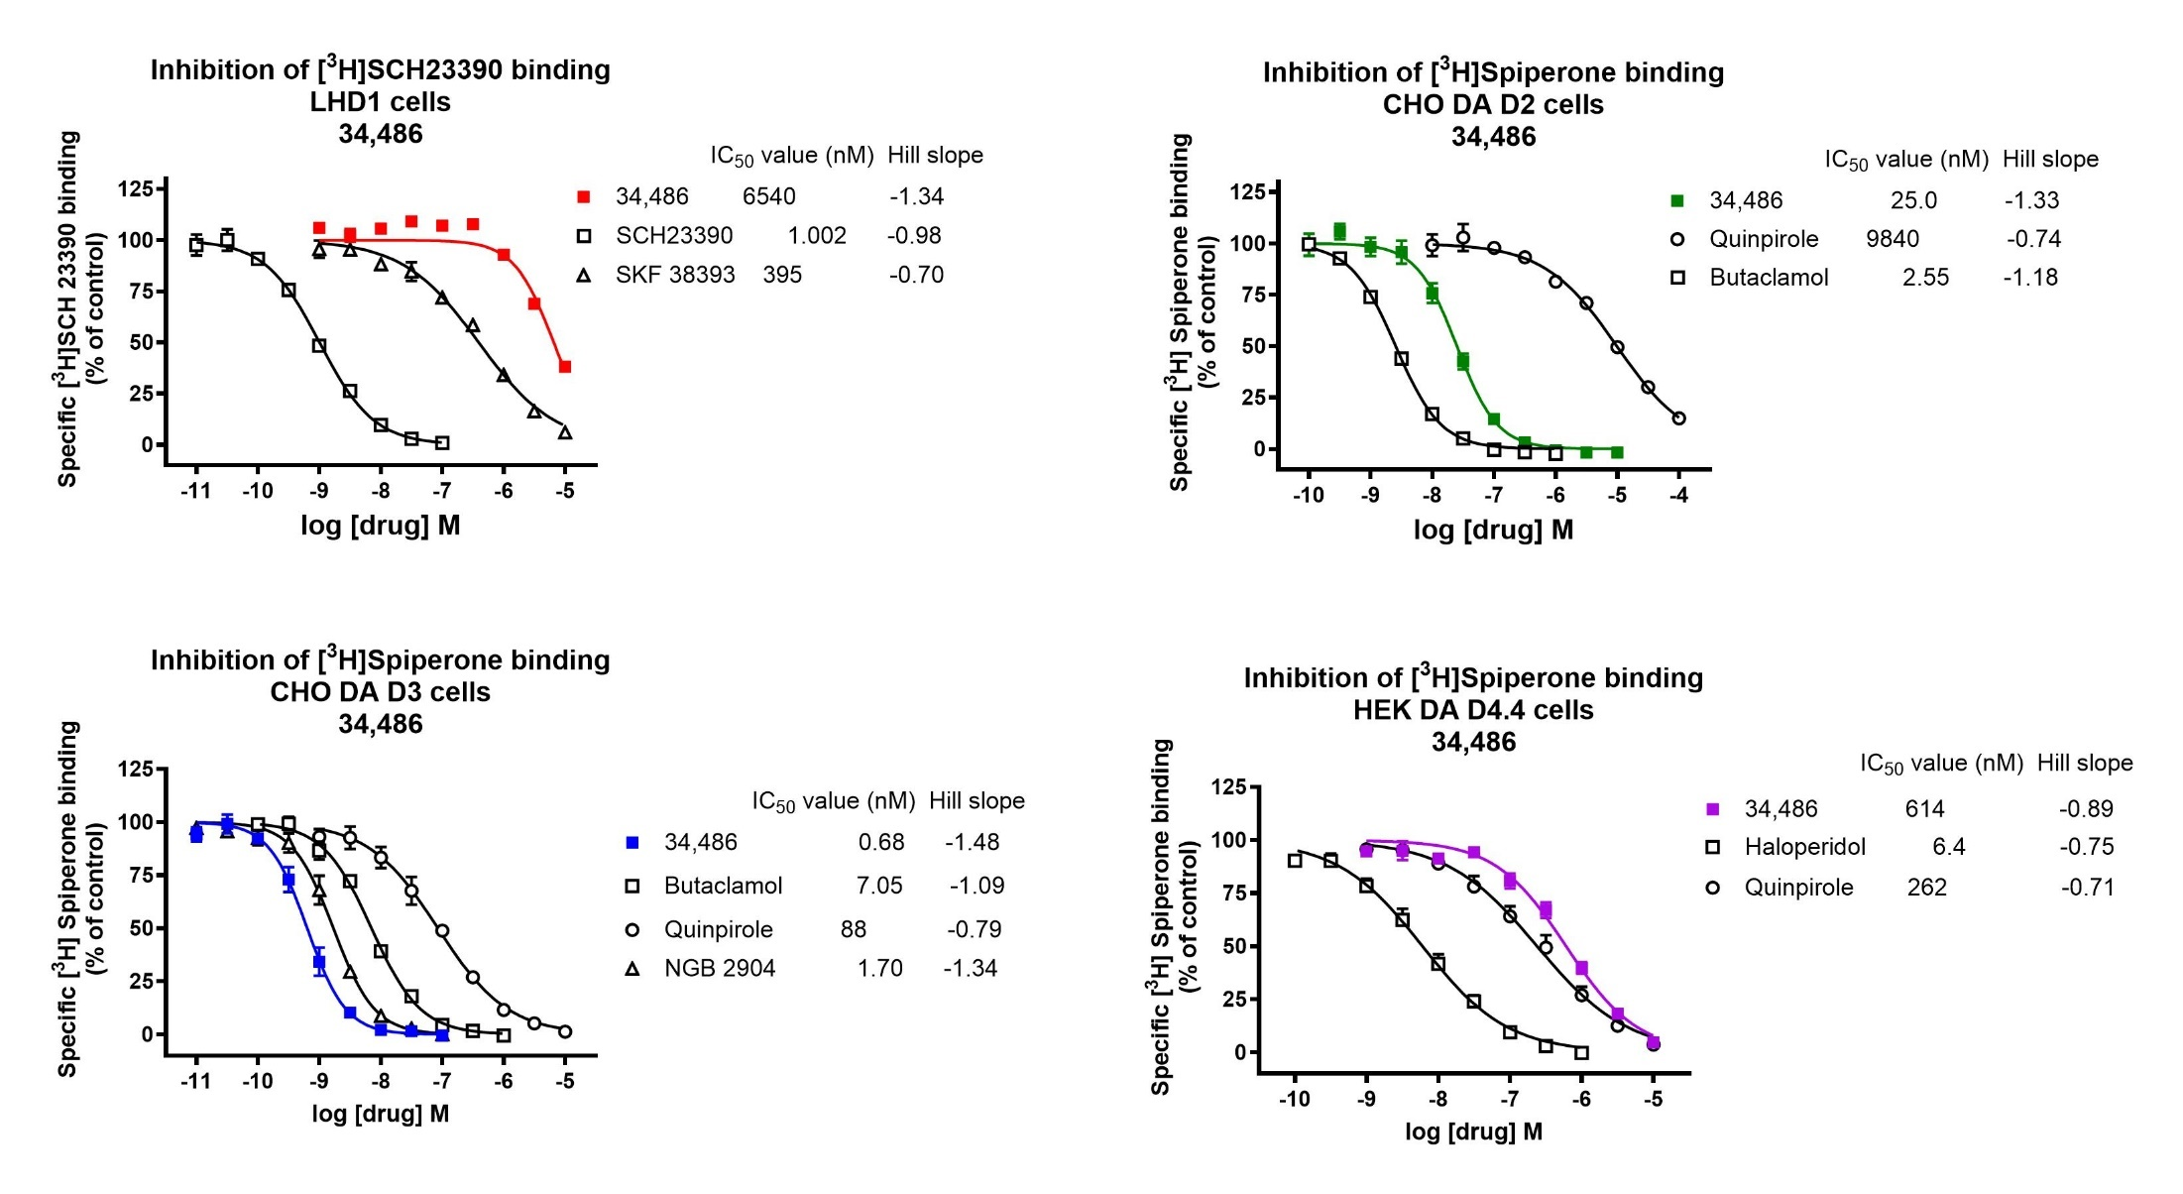

Serotonin receptors binding results

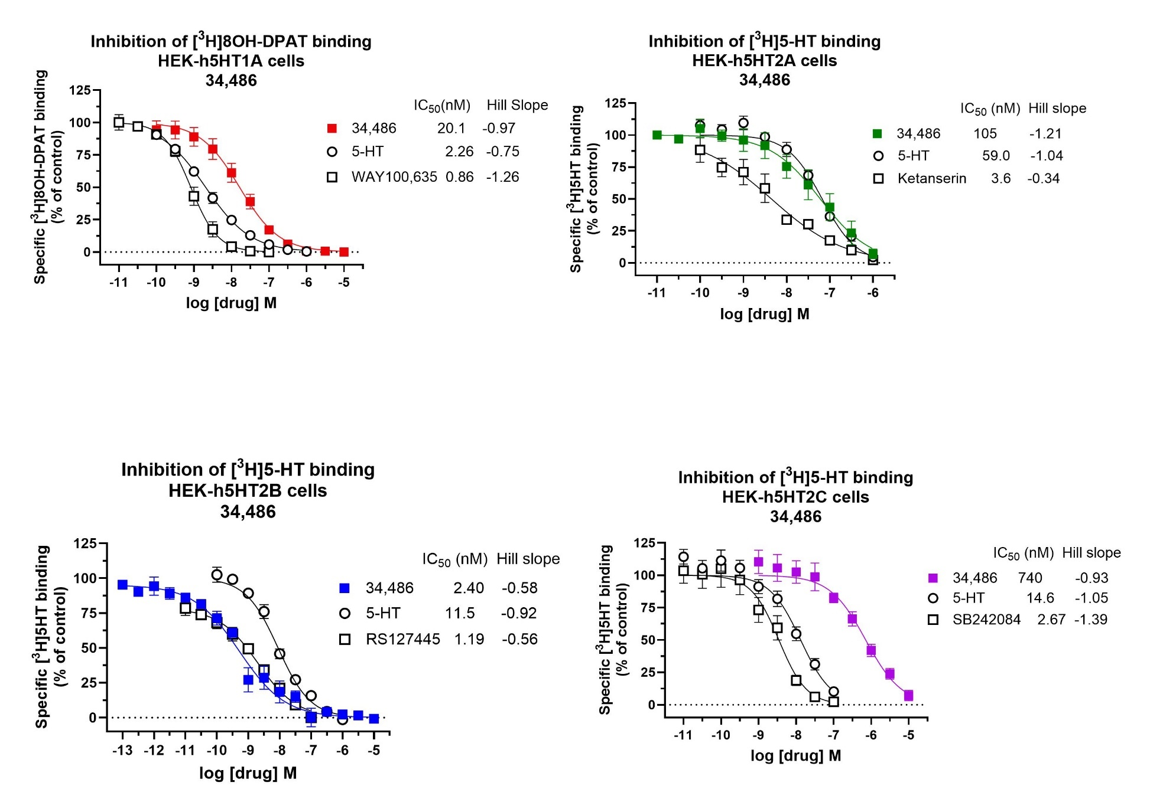

DA D2 functional results
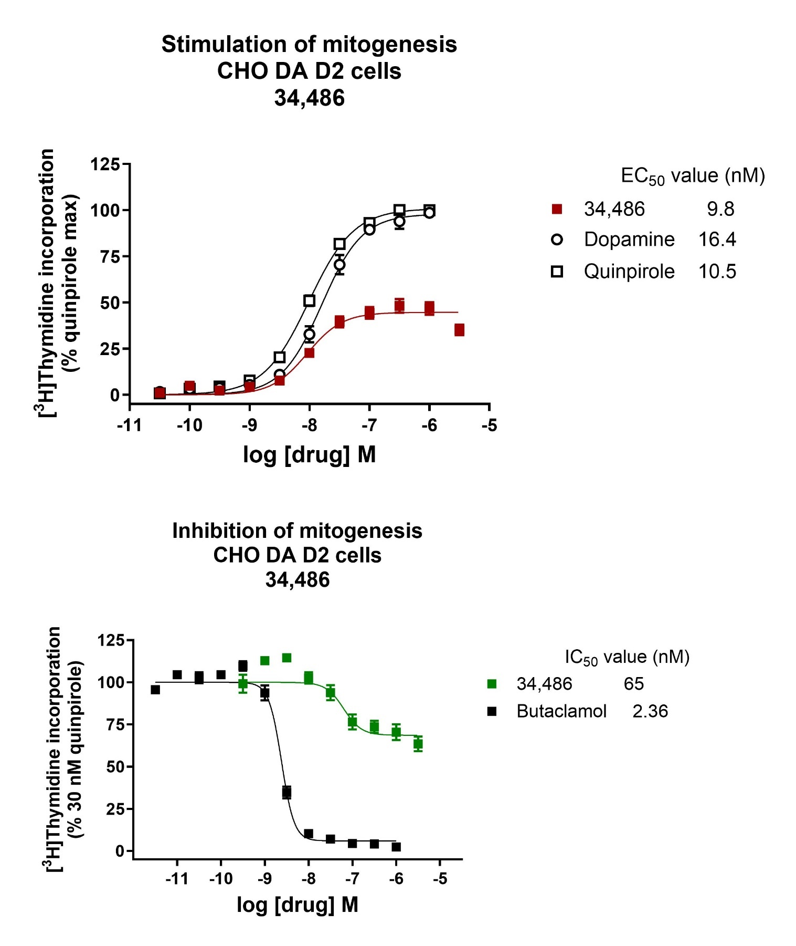

DA D3 functional results
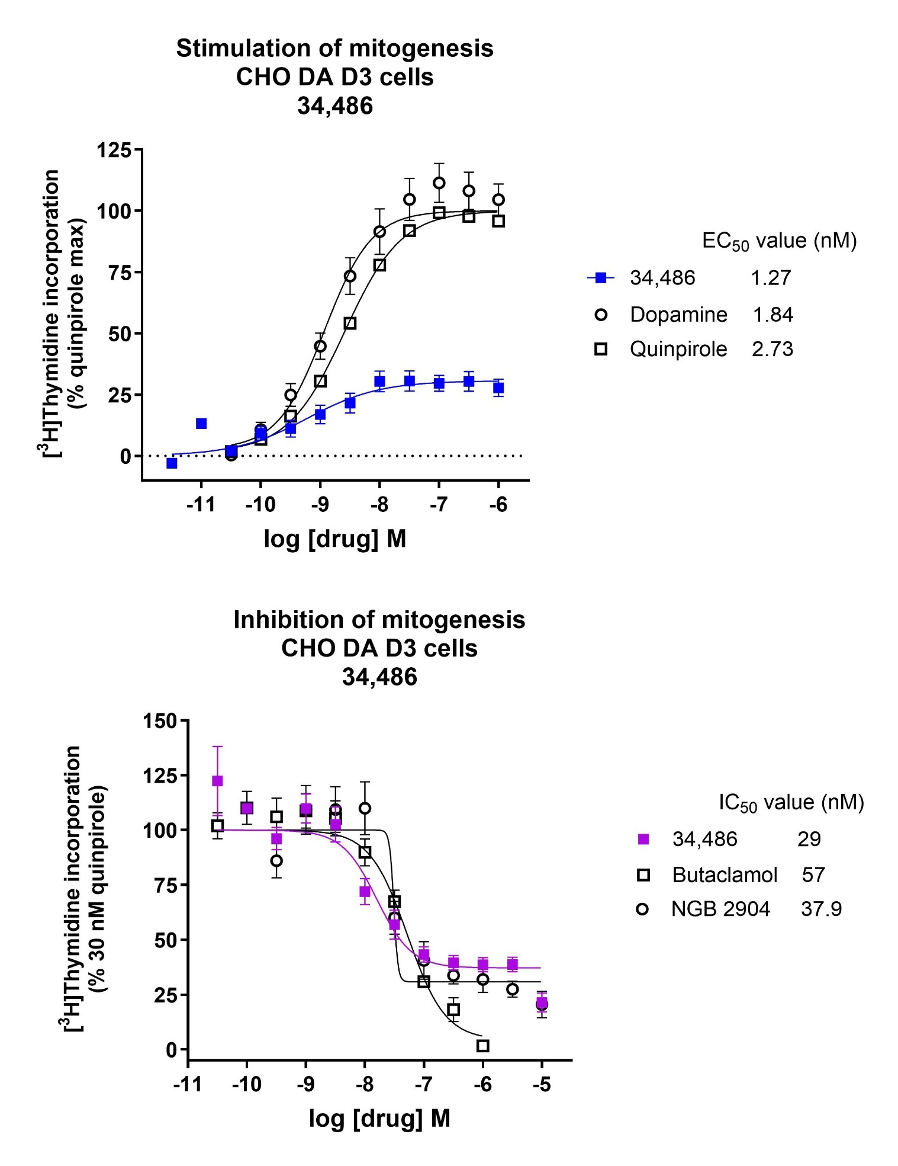

DA D4 functional results
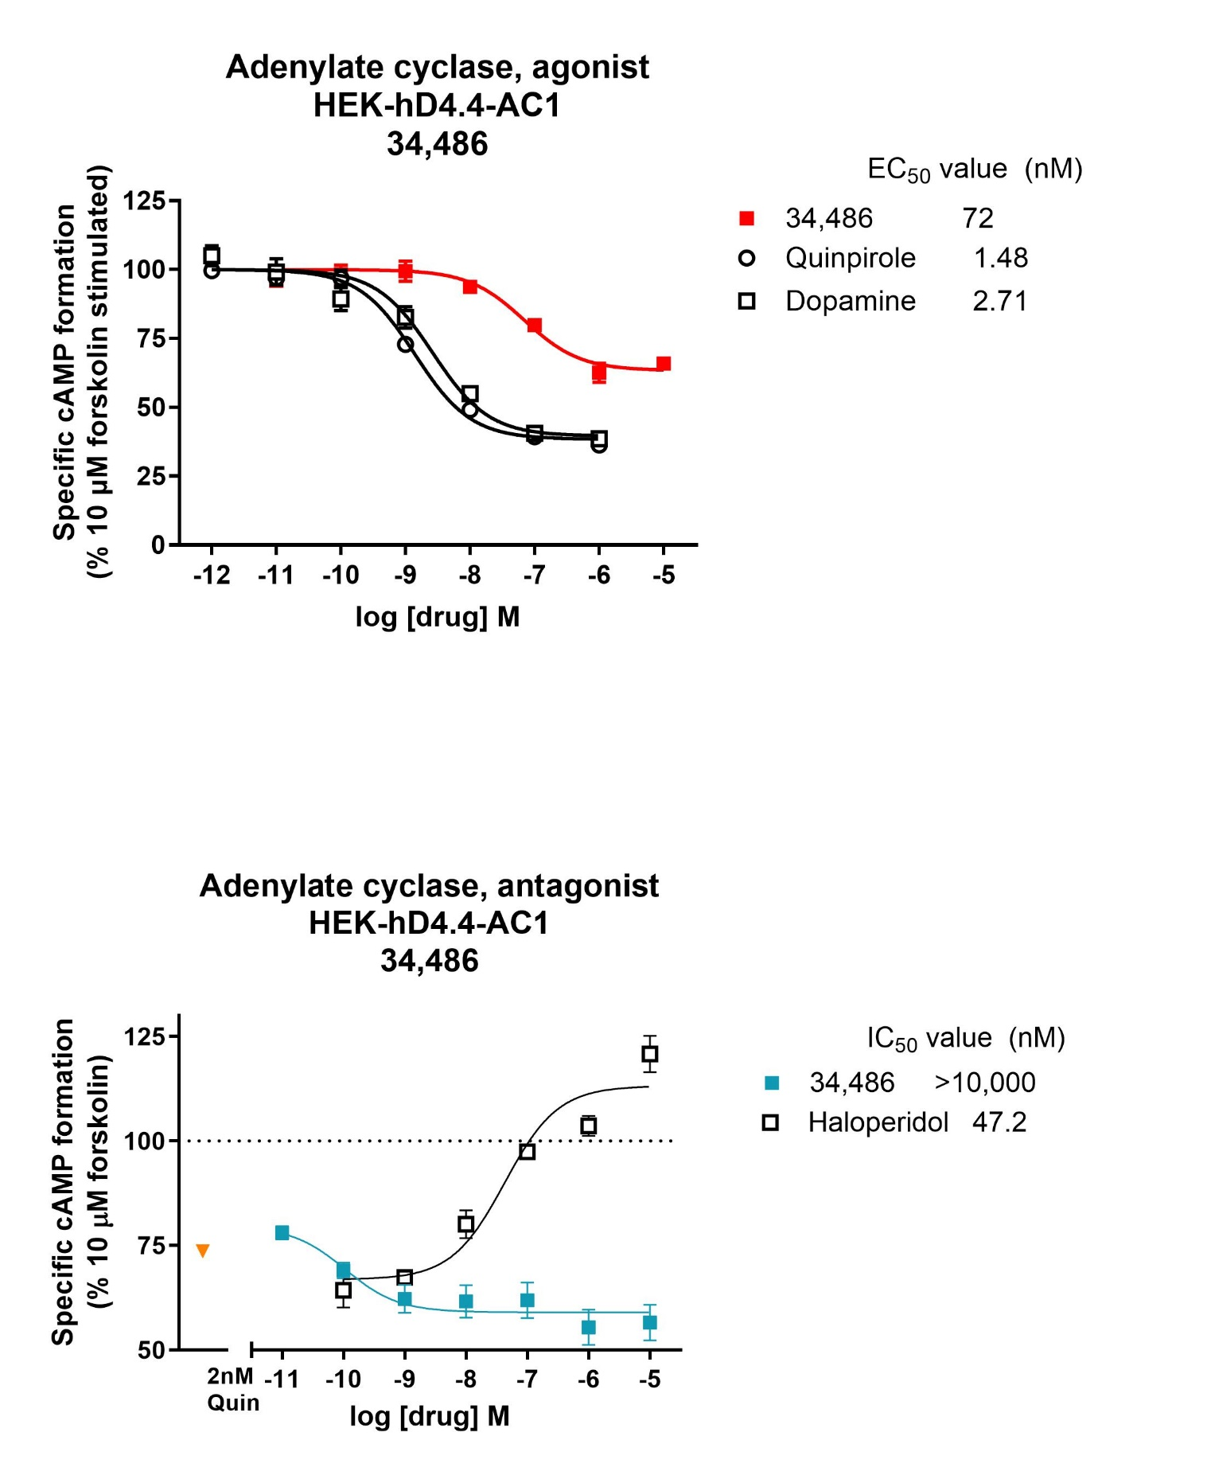

5HT1A functional results
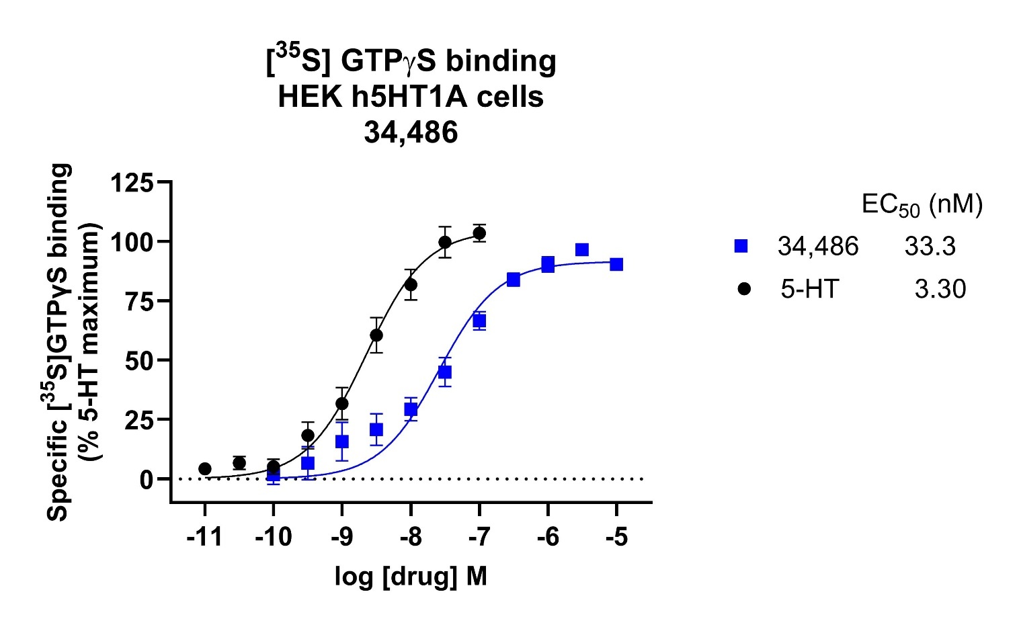

5HT2A functional results
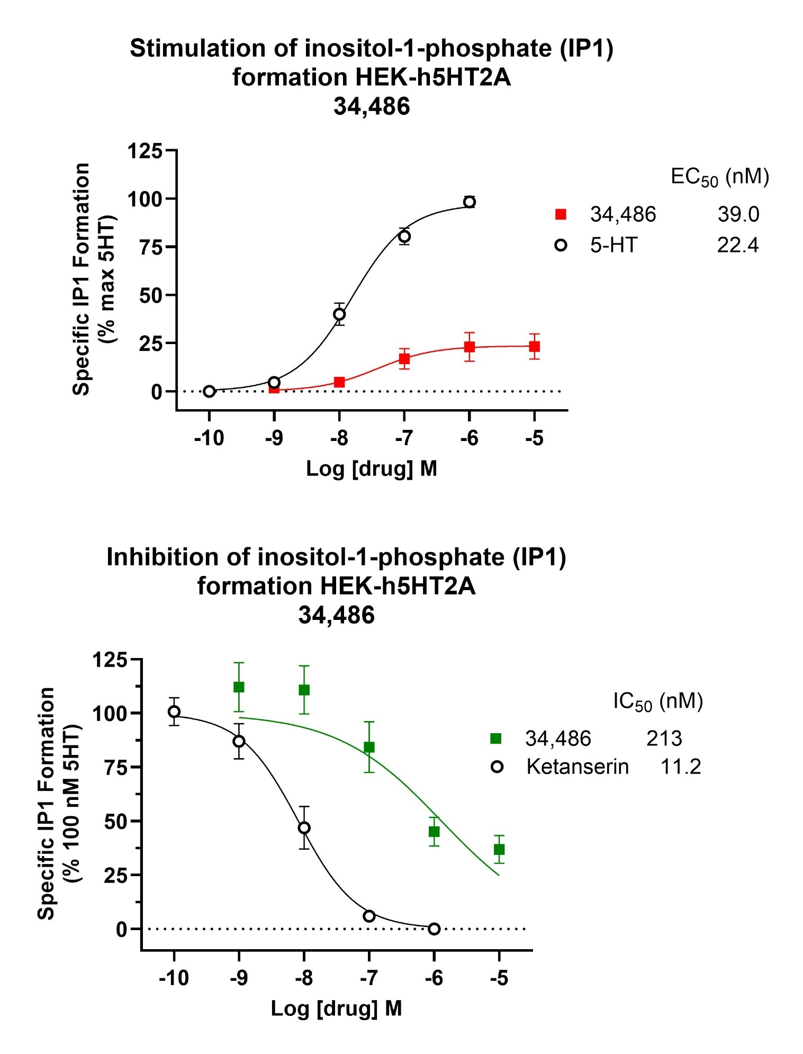

5HT2B functional results
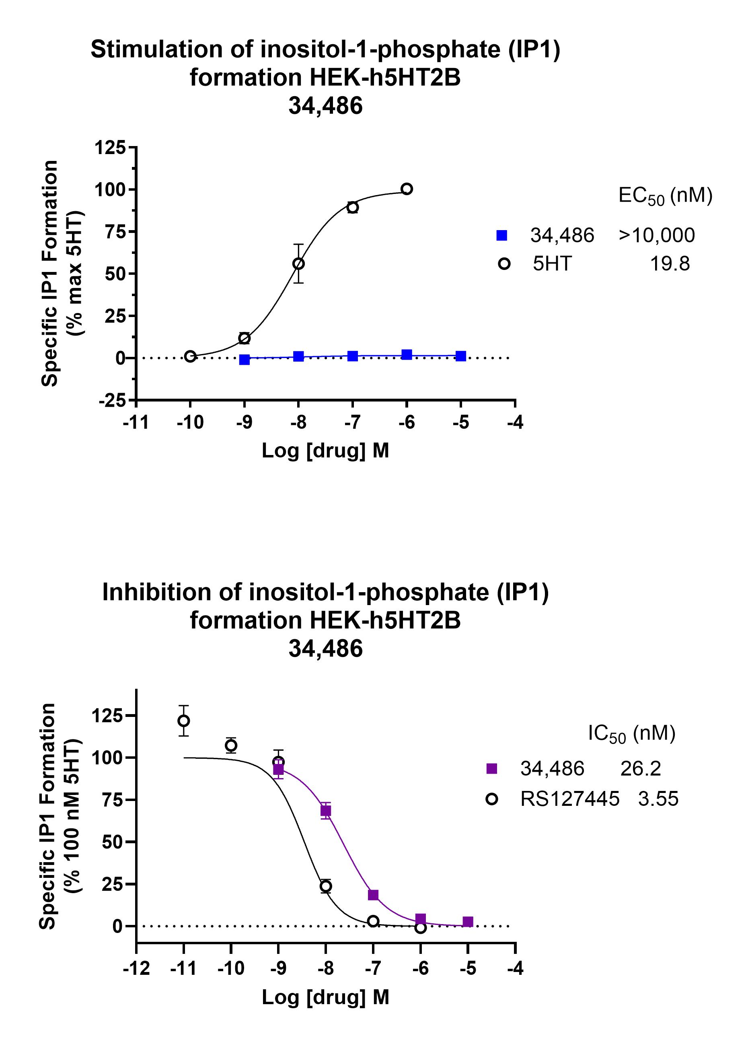

METHODS

Unknowns are weighed and dissolved in DMSO to make a 10 mM stock solution. An initial dilution to 50 μM in assay buffer or water for binding is made. For binding and most functional assays, subsequent dilutions are made with buffer supplemented with DMSO, maintaining a final concentration of 0.1% DMSO in all wells. Pipetting is conducted using a Biomek 4000 robotic workstation.

1. [³H]SCH23390 binding to the DA D1 receptor in clonal cells
The method was adapted from Eshleman AJ, Wolfrum KM, Hatfield MG, Johnson RA, Murphy KV, and Janowsky A. (2013) Substituted methcathinones differ in transporter and receptor interactions.
Concentrations of #34,486 tested
Assay | Concentration Range
Binding:
DA D1 | 1 nM-10μM
DA D2 | 0.1 nM-10μM
DA D3  DA D4.4 | 0.01 nM-100 nM  1 nM-10μM
Functional:
DA D1
DA D2 | 0.03 nM-3 μM
DA D3  DA D4.4 | 3 pM-10μM  0.01 nM-10μM

Biochemical Pharmacology, 85:1803-1815Mouse fibroblast cells expressing the human D1 receptor at high density (LhD1 cells) are used. The cells are grown to confluence in Dulbecco’s Minimal Essential Medium (DMEM) containing 10% FetalClone1 serum (FCS, HyClone), 0.05% penicillin-streptomycin (pen-strep), and 200 µg/ml of Geneticin (G418). Three confluent 150 mm plates yield enough membranes for 3 assay plates with ~10-15 µg protein per well. The cells from 3 150 mm plates are scraped and centrifuged at 500 x g for 5 minutes. The pellet is overlaid with 2 ml of 50 mM Tris-HCl buffer (pH 7.4) and frozen at -70ºC. On the day of experiment, the pellet is homogenized in 30 ml assay buffer (50 mM Tris-HCl, pH 7.4, containing 120 mM NaCl, 5 mM KCl, 2 mM CaCl₂, and 1 mM MgCl₂) with a polytron. Cell homogenate (100 µl) is added to wells containing 800 µl of test drug or buffer. After 10 minute preincubation, 100 µl of [³H]SCH-23390 (0.18 nM final concentration) is added. The plates are incubated at 25°C for 60 minutes. The reaction is terminated by filtration through polyethylenimine-soaked (0.05%) filters using a Tomtec 96 well harvester and radioactivity on the filters is counted using a Perkin Elmer microbetaplate 1405 liquid scintillation counter. Nonspecific binding is determined with 1 µM SCH-23390.

2. Functional assay: Adenylate cyclase / cAMP Functional Assay
Mouse glioma cells expressing the monkey D1 receptor at low density (C₆D1 low-D1-density cells) are used. The cells are grown on 48-well plates in DMEM containing 10% FCS, 0.05% pen-strep and 2 μg/ml of puromycin. When the wells reach 80-90% confluence, DMEM is removed, and each well is rinsed once with 0.5 ml of EBSS buffer (116.4 mM NaCl, 5.4 mM KCl, 1.2 mM Na₂HPO₄, 1.3 mM CaCl₂, 1.2 mM MgSO₄, 15 mM HEPES, and 10 mM glucose, pH 7.4 at room temperature) containing 0.1% ascorbic acid, 2% bovine calf serum (BCS) and 0.11% 3-isobutyl-1-methyl-xanthine (IBMX), an inhibitor of cAMP phosphodiesterase. The cell number of C₆D1 low-D1-density cells per 48-well plate is determined. Two hundred thousand cells per well is optimal for the use of the Cyclic AMP EIA kit (Cayman Chemical). The 48-well plates are pre-incubated for 20 minutes at 37°C with EBSS buffer alone, then incubated for an additional 20 minutes with the test compound diluted in EBSS buffer (final volume 1 ml) in triplicate. The EBSS buffer is removed and 0.05 ml of 3% TCA is added to each well. After 1 hour, the supernatant is diluted 1:50, and 50 µl of diluted supernatant is added to the Cyclic AMP EIA test plate in a final assay volume of 200 µl/well. The assay is incubated for 18 hours at 4ºC. The supernatant is aspirated and each well is rinsed five times with 300 μl EIA buffer. Developing reagent (200 μl, Ellman’s) is added to each well and incubated at room temperature for 2 hours while gently rotating. The plate is read in a microplate spectrophotometer at 405 nM (BioRad Benchmark Plus). Linearity of signal is observed at cAMP amounts up to ~100 pg.

3. [³H]Spiperone binding to DA D2, DA D3 and DA D4.4 receptors in clonal cells
The method was adapted from Eshleman AJ, Wolfrum KM, Hatfield MG, Johnson RA, Murphy KV, and Janowsky A. (2013) Substituted methcathinones differ in transporter and receptor interactions. Biochemical Pharmacology, 85:1803-1815.
Chinese hamster ovary cells expressing the human D2 or D3 receptor (CHOp-D2 or CHOp-D3) are used. D2 and D3 cells are grown to confluence in alpha-minimal essential medium (alpha-MEM) containing 10% fetal bovine serum (FBS, Atlas Biologicals), 0.05% pen-strep, and 200 µg/ml of G418. Human embryonic kidney cells coexpressing the human D4.4 receptor and adenylate cyclase type I (HEK-D4.4-AC1) are grown in DMEM supplemented with 5% FetalClone (HyClone), 5% bovine calf serum (BCS), 0.05% pen-strep, 2 µg/ml of puromycin and 200 µg/ml of hygromycin. Membranes are prepared according to the procedures described for D1 cells, using 50 mM Tris (pH 7.4 at 4ºC). Assay buffer contained 120 mM NaCl, 5 mM KCl, 1.5 mM CaCl₂, 4 mM MgCl₂, 1 mM ascorbic acid and 1 mM EDTA, pH 7.4 at 37ºC). One confluent 150 mm plate of D2 or D4.4 cells, or two confluent plates of D3 cells, resuspended in 12 ml of binding buffer, yields enough membranes for 1 assay plate with ~8-11 (D2), ~12-18 (D3), or ~14-25 (D4.4) µg protein per well. Proteins were determined using BCA assay (Pierce). Cell homogenate (100 µl) is added to wells containing 800 µl of test drug or buffer. After 10 minutes, 100 µl of [³H]spiperone (specific activity 80.2, 0.2-0.3 nM final concentration) is added. The plates are incubated at 37°C for 60 minutes. The reaction is terminated by filtration through polyethylenimine-soaked (0.05%) filters using a Tomtec 96 well harvester. Radioactivity on the filters is counted using a Perkin Elmer microbeta counter. Nonspecific binding is determined with 1 µM chlorpromazine (D2 and D3) or 1 µM haloperidol (D4.4).

4. DA D2 Mitogenesis Functional Assay
CHOp-D2 cells are maintained in alpha-MEM with 10% FBS, 0.05% pen-strep, and 400 µg/ml of G418. To measure D2 stimulation of mitogenesis (agonist assay) or inhibition of quinpirole stimulation of mitogenesis (antagonist assay), CHOp-D2 cells are seeded in a 96-well plate at a concentration of 5,000 cells/well. The cells are incubated at 37ºC in alpha-MEM with 10% FBS, pen-strep and G418. After 48-72 hours, the cells are rinsed twice with serum-free alpha-MEM and incubated for 24 hours at 37ºC. Serial dilutions of test compounds are made by the Biomek robotics system in serum-free alpha-MEM. In the functional assay for agonists, the medium is removed and replaced with 100 µl of test compound in serum-free alpha-MEM. In the antagonist assay, the serial dilution of the putative antagonist test compound is added in 90 μl (1.1X of final concentration) and 300 nM quinpirole (30 nM final) is added in 10 μl. After another 24-hour incubation at 37ºC, 0.3 µCi of [³H]thymidine in alpha-MEM supplemented with 10% FCS is added to each well and the plates are further incubated for 2 hours at 37ºC. The cells are trypsinized by addition of 10X trypsin solution (1% trypsin in calcium-magnesium-free phosphate-buffered saline) and the plates are filtered and counted as usual. Quinpirole is run each day as an internal control and dopamine is included for comparative purposes.

5. DA D3 Mitogenesis Functional Assay
CHOp-D3 cells are maintained in alpha-MEM with 10% fetal bovine serum (FBS, Atlas Biologicals), 0.05% pen-strep, and 200 µg/ml of G418. To measure D3 stimulation of mitogenesis (agonist assay) or inhibition of quinpirole stimulation of mitogenesis (antagonist assay), CHOp-D3 cells are seeded in a 96-well plate at a concentration of 5,000 cells/well. The cells are incubated at 37ºC in alpha-MEM with 10% FBS, pen-strep and G418. After 48-72 hours, the cells are rinsed twice with serum-free alpha-MEM and incubated for 24 hours at 37ºC. Serial dilutions of test compounds are made by the Biomek robotics system in serum-free alpha-MEM. In the functional assay for agonists, the medium is removed and replaced with 100 µl of test compound in serum-free alpha-MEM. In the antagonist assay, the serial dilution of the putative antagonist test compound is added in 90 μl (1.1X of final concentration) and 300 nM quinpirole (30 nM final) is added in 10 ul. After another 16-hour incubation at 37ºC, 0.3 µCi of [³H]thymidine in alpha-MEM supplemented with 10% FBS is added to each well and the plates are further incubated for 2 hours at 37ºC. The cells are trypsinized by addition of 10X trypsin solution (1% trypsin in calcium-magnesium-free phosphate-buffered saline) and the plates are filtered and counted as usual. Quinpirole is run each day as an internal control and dopamine is included for comparative purposes.

6. DA D4.4 Adenylate cyclase / cAMP Functional Assay
HEK-D4.4-AC1 cells are grown to confluence on 150 mM plates. Cells are plated at a density of 200,000 cells per well in 48 well plates in DMEM supplemented with 5% FetalClone, 5% BCS and pen-strep. After ~36 hours, the medium is changed to DMEM supplemented with 10% charcoal-stripped FetalClone and pen-strep. The medium is removed ~18 hr later. For agonist assays, 0.8 ml EBSS (116 mM NaCl, 22 mM glucose, 15 mM HEPES, 8.7 mM NaH₂PO₄, 5.4 mM KCl, 1.3 mM CaCl₂, 1.2 mM MgSO₄, 1 mM ascorbic acid, 0.5 mM IBMX [3-isobutyl-1-methyl-xanthine] and 2% BCS, pH 7.4 at 37ºC) is added, cells are incubated 20 min, agonists are added, and, after 20 min incubation, 10 µM forksolin is added in a final volume of 1 ml. For antagonists, 0.7 ml EBSS is added, cells are incubated for 10 min, antagonists are added, cells are incubated 10 min, 2 nM quinpirole is added, and after 20 min incubation, 10 µM forksolin is added in a final volume of 1 ml. For all conditions, after 20 min incubation with forskolin, the reaction is terminated by aspiration of the buffer, and 0.1 ml trichloroacetic acid is added. Plates are incubated for 2 hr on a rotator. Adenylate cyclase activity is measured using a cyclic AMP EIA kit (Cayman). Aliquots (15 µl) of each well are diluted to 200 ul with EIA buffer from the kit, and 50 µl of the dilution is added to the EIA plate. After addition of tracer and monoclonal antibody, the EIA plates are incubated for 18 hr at 4ºC. The reaction is aspirated, plates are washed 5x300 µl with wash buffer, and Ellman’s reagent is added. After two hour incubation in the dark on a rotator, the plates are read at 410 nm. Basal cAMP is subtracted from all values. D4.4 receptor agonists inhibit forskolin-stimulated cAMP formation, maximal inhibition is defined with 1 µM quinpirole. Data normalized to percent forskolin stimulation are shown in the graph. The maximal effect is normalized to maximal effect of quinpirole in the tables. For antagonists, maximal reversal of inhibition of cAMP formation is defined with 10 µM haloperidol.

4. [³H]8-OH-DPAT binding to 5HT1A receptors in clonal cells
The method was adapted from Gatch MB, Forster MJ, Janowsky A and Eshleman AJ. (2011) Abuse liability profile of three substituted tryptamines. J Pharmacol Exp Ther. 338:280-9. PMID 21474568.
Human embryonic kidney cells expressing the human 5HT1A receptor (HEK-h5HT1a) are used. The cells are grown to confluence in DMEM containing 10% FetalClone (FC. HyClone), 0.05% penicillin-streptomycin (pen-strep), and 300 µg/mL of Geneticin (G418). The cells are scraped from 150 mm plates into phosphate-buffered saline and centrifuged at 270 x g, 1200 rpm, for 10 minutes. The cell pellet is homogenized in 50 mM Tris-HCl (pH 7.7) with a polytron, and centrifuged at 27,000  g. The homogenization and centrifugation are repeated to wash any remaining 5-HT from the growth media. The final pellet is resuspended at 0.5 mg protein/mL in assay buffer (25 mM TrisHCl, pH 7.4, containing 100 µM ascorbic acid and 10 µM pargyline). The assay is performed in triplicate in a 96-well plate. The reaction mixture contains unknown compound, 100 µl of cell homogenate (0.05 mg protein/well) and 100 µl of [3H]8-OH-DPAT (0.5 nM final concentration, 170 Ci/mmol, Perkin Elmer) in a final volume of 1 ml. Nonspecific binding is determined with 1.0 µM dihydroergotamine. The plates are incubated at room temperature for 60 minutes and then filtered through polyethylenimine-soaked (0.05%) filtermats on a Tomtec cell harvester. The filters are washed with cold 50 mM Tris buffer (pH 7.7) for 6 sec, dried, spotted with scintillation cocktail, and counted for 2 minutes after a 4 hr delay on a Perkin Elmer microbetaplate 1405 liquid scintillation counter. IC₅₀ values are calculated with GraphPad Prism, and IC₅₀ values are converted to Ki values using the Cheng-Prusoff correction.
Concentrations of #34,486 tested
Assay | Concentration Range
Binding:
5HT1A | 0.1 nM-10μM
5HT2A | 0.01 nM-1μM
5HT2B  5HT2C | 0.1 pM-10μM  1 nM-10μM
Functional:
5HT1A | 0.1 nM-10μM
5HT2A | 1 nM-10μM
5HT2B  5HT2C | 1 nM-10μM

6. [³⁵S] GTPγS binding to 5HT1A receptors in clonal cells (functional assay)
Method adapted from: A Newman-Tancredi et al., Agonist and antagonist actions of antipsychotic agents at 5HT1A receptors: a [³⁵S]GTPγS binding assay. Eur J Pharmacol 355 (1998) 245-256.

Five 15 cm plates of HEK-h5HT1A cells, 80-90% confluent, provide enough membranes for one assay plate (4 drug curves). GTPγS assay buffer (20 mM HEPES, pH 7.4, 10 mM MgCl₂, 100 mM NaCl, and 0.2 mM DTT) is used throughout the assay. The cells are scraped from the plates into buffer, centrifuged at 200 rpm for 15 min, the supernatant is removed, and the pellet is homogenized in 10 ml buffer/ plate of cells. The homogenate is centrifuged at 17,500 rpm for 15 min, and the resulting pellet is washed 2 times by homogenization in 10 ml buffer and centrifugation to remove serotonin that was present in the growth medium. The supernatant is removed, and the final pellet from 5 plates is resuspended in 10 ml of assay buffer.

Cell membranes (40-75 μg protein) are preincubated (10 min, room temperature) with test compound in duplicate in assay buffer. The reaction is initiated by the addition of GDP (3 μM) and [³⁵S]GTPγS (0.1 nM, 1350 Ci/mmol, Perkin Elmer, ~150,000 cpm) in a final volume of 1 ml. The reaction is incubated for 60 min at room temperature on a rotating platform. Non-specific binding is defined with 1 μM WAY-100635. Agonist efficacy is expressed relative to that of 5HT (or other agonist as directed by the project officer), tested at a maximally effective concentration (100 nM) in each experiment. A dose response curve with the prototypical full agonist serotonin is conducted in each experiment to identify full and partial agonist compounds. Experiments are terminated by rapid filtration over Filtermat A with ice-cold saline using a Tomtec harvester and radioactivity determined using a Perkin Elmer microbetaplate counter. EC₅₀ values are calculated with GraphPad Prism and maximal effect for a given drug each day is normalized to the maximal effect of serotonin.
7. [³H]5-HT binding to 5HT2A, 5HT2B and 5HT2C receptors in clonal cells
The method was adapted from Eshleman AJ, Wolfrum KM, Hatfield MG, Johnson RA, Murphy KV, and Janowsky A. (2013) Substituted methcathinones differ in transporter and receptor interactions. Biochemical Pharmacology, 85:1803-1815.
Human embryonic kidney cells expressing the human 5HT2A receptor (HEK-h5HT2A), human 5HT2B receptor (HEK-h5HT2B) or human 5HT2C receptor (HEK-h5HT2C) are used. The cells are grown until confluent on 15 cm plates. Media is removed, cells are rinsed with phosphate-buffered saline (PBS), scraped into 10 ml PBS and centrifuged at 1000xg for 10 min. The pellet is resuspended in 5 ml 50 mM Tris (pH 7.4 at 4ºC) and polytronned at setting 6 for 5 sec. The homogenate is centrifuged at 15,000 rpm for 20 min. To minimize the residual 5HT concentration, the pellet is resuspended in buffer, polytronned, and centrifuged as above an additional two times. The final pellet is resuspended in 3.25 ml buffer/plate for 5HT2B cells or 10 ml buffer/plate of 5HT2A cells or 5HT2C cells.
The binding assay includes 50 µl drug, 5HT or buffer, 50 µl cell homogenate, 50 µl [³H]5HT (2 to 4 nM, final) and buffer (50 mM Tris, pH 7.4 at 37ºC, with 0.1% ascorbic acid, 5 mM CaCl₂ and 10 µM pargyline) in a final volume of 250 µl. Specific binding is defined as the difference between total binding and binding in the presence of 10 µM 5HT. The reaction is incubated for 40 min at 37ºC, and terminated by filtration thru Perkin Elmer A filtermats presoaked in 0.05% polyethylenimine using a Tomtec 96-well harvester. Radioactivity remaining on filters is counted on a Perkin Elmer microbetaplate 1405 liquid scintillation counter.
8. Inositol-1-phosphate (IP-1) formation in 5HT2A, 5HT2B and 5HT2C receptor clonal cells
HEK-h5HT2A, HEK-h5HT2B or HEK-h5HT2C cells are used as the tissue source and the IP-One Gq ELISA kit is used (CisBio, Bedford, MA). The day before the experiment, cells are plated in 24 well plates at a density of 400,000 cells per well using DMEM supplemented with charcoal-stripped FetalClone. 5HT2C cells are incubated with 450 μg G418/ml medium until the experimental day. On the day of the experiment, medium is removed, cells are rinsed with 1 ml unsupplemented medium, and then preincubated with 1 ml unsupplemented medium for 1 hr. Drugs are made up in stimulation buffer supplied in the kit. Medium is removed from the well, test compounds or serotonin or antagonist or buffer is added, and the cells are incubated for 1 hour. The cells are lysed for 30 min, and 50 μl of cell lysate is added to the IP-1 plates. After the addition of appropriate antibodies, the plates are incubated overnight at 4ºC, washed 6 times, incubated with substrate for 20 min, and, after termination of the reaction, the plate is read on a plate reader at 450 nm with a correction at 620 nm. Agonists are normalized to the maximal stimulation by serotonin, and antagonists are tested in the presence of 100 nM serotonin and normalized to the inhibition by 10 μM ketanserin (5HT2A), 100 nM RS 127445 (5HT2B), or 1 μM SB 242084 (5HT2C). The 5HT2C receptor may have consititutive activity, and compounds that inhibit basal activity in the agonist assay may be inverse agonists.
Data analysis: For binding, data are normalized to the binding in the absence of drug. Three or more independent competition experiments are conducted with duplicate determinations. GraphPAD Prism is used to analyze the data, with IC₅₀ values converted to K_{i} values using the Cheng-Prusoff equation (K_{i}=IC₅₀/(1+([drug*]/K_{d} drug*))), where drug* is the labeled ligand used in the binding assays. The K_{d} values used in the equations are 0.62 nM for [³H]SCH-23390 at DA D1 receptors, 0.083 nM for [³H]spiperone at DA D2 receptors, 0.264 nM for [³H] spiperone at DA D3 receptors, 0.262 nM for [³H] spiperone at DA D4.4 receptors, 5.02 nM for [³H]8-OH-DPAT at 5HT1A receptors and 27.37 nM, 3.56 nM and 10.02 nM for [³H]5HT at 5HT2A, 5HT2B and 5HT2C receptors, respectively. For functional assays, GraphPAD Prism is used to calculate either EC₅₀ (agonists) or IC₅₀ (antagonists) values using data expressed as pg cAMP for adenylate cyclase activity, % quinpirole-stimulation for mitogenesis, or % serotonin-stimulation for GTPγS binding and IP-1 formation.

